Lahore Garrison University
DHA Phase 6 Lahore



Student Name | Ibrahim Haider
Student Roll No | Fa-23/BSCS/130
Section | D
Subject | Web Technology
Instructor Name | Mr. Muhammad Yousaf

Lab 1: Setting up the Web Development Environment
- Objectives:
  - Configure a developer environment (VS Code, browsers, Git) and understand the basic web stack.
- Tools/Tech:
  - VS Code, Chrome/Firefox, Git/GitHub, Node.js (optional)
- Tasks/Steps:
- Install VS Code and essential extensions (Live Server, Prettier).
- Install Git and create a GitHub account/repository for the course.
- Clone a starter repo and run Live Server.
- Create a README with project structure and commit changes.
- Deliverables:
  - GitHub repo with initial commit, README, and a simple index.html served via Live Server.
  - Environment installed and verified (4), correct Git workflow C commit history (4), README quality (2).
Solution:
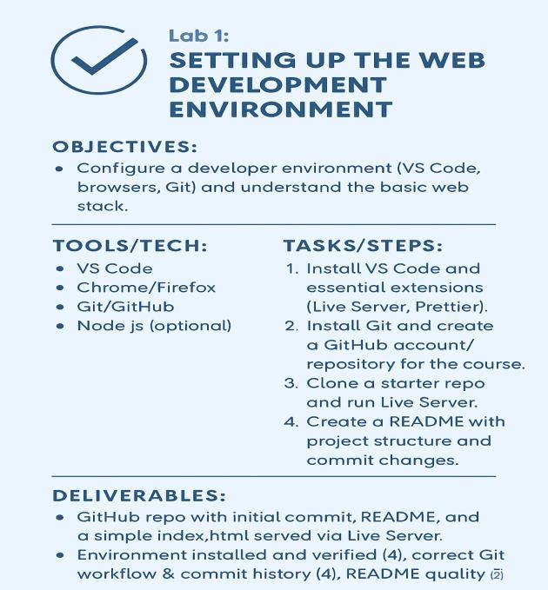

⬛ Complete Installation Steps for Web Development Setup

Install a Code Editor

  - Download and install Visual Studio Code
  - Optional: Install extensions like Live Server, Prettier, and ESLint
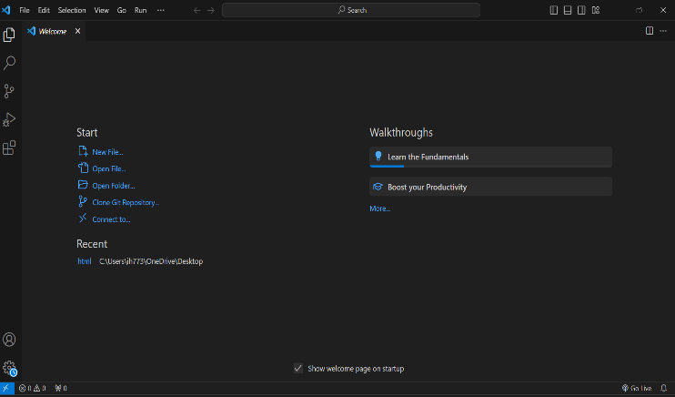 | 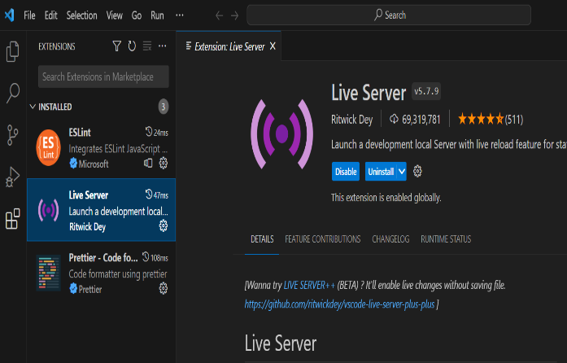
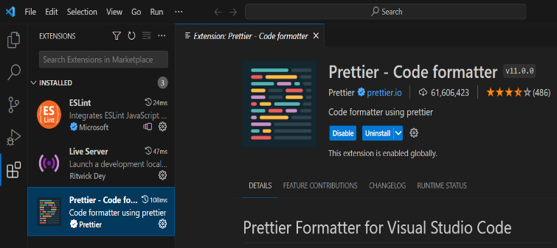 | 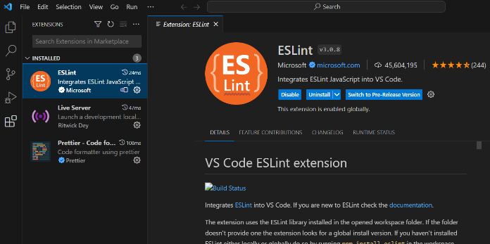

Install Web Browsers

  - Ensure you have the latest versions of Google Chrome and Mozilla Firefox for testing

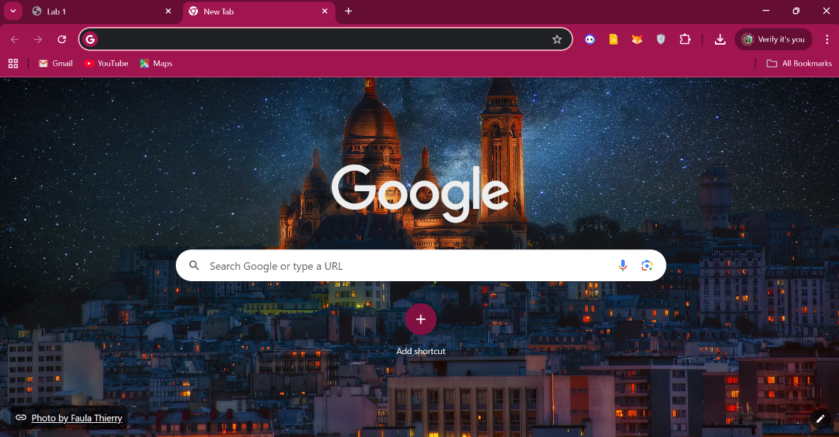

Set Up Version Control

  - Install Git
  - Configure Git with your username and email:
  - git config --global user.name "Your Name"
  - git config --global user.email "you@example.com"

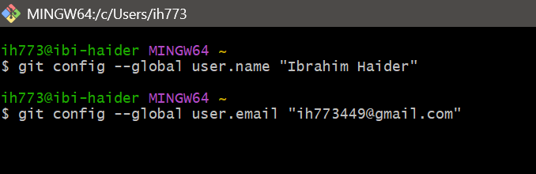

Create a Project Folder

  - Make a folder named WebDevLab1 on your desktop or preferred location
  - Inside, create subfolders: html, css, js, and assets

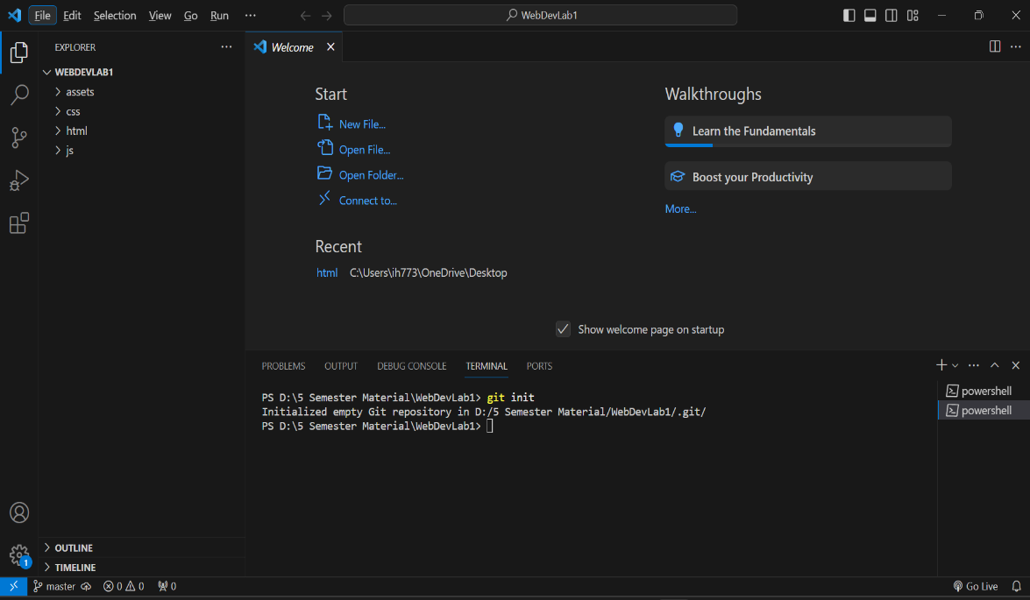

Initialize Git Repository

  - Open the folder in VS Code
  - Run:
  - git init

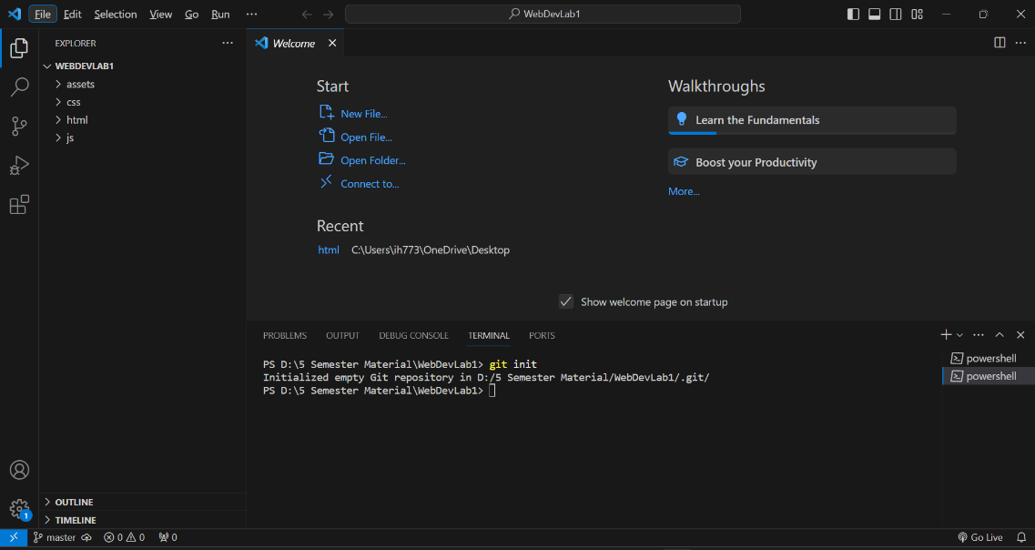

Install Live Server

  - In VS Code, go to Extensions → Search for “Live Server” → Click Install
  - Right-click your index.html file → “Open with Live Server”

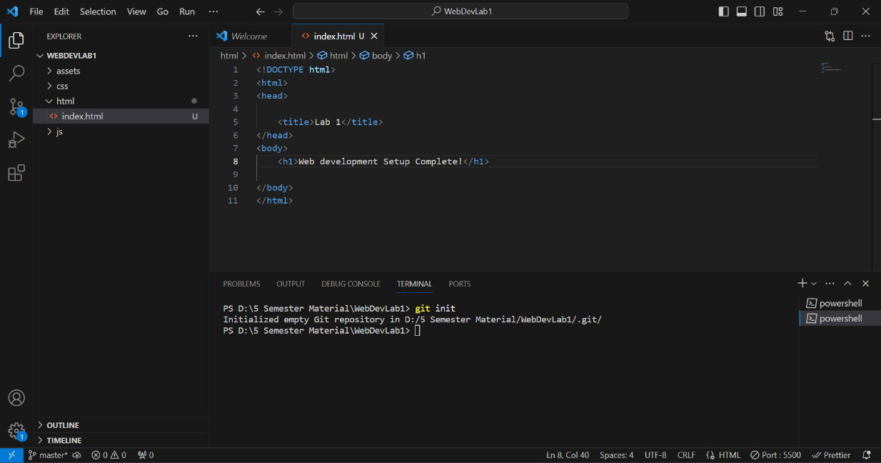

Verify Setup

  - Open index.html and add:
  - <!DOCTYPE html>
  - <html>
  - <head><title>Lab 1</title></head>
  - <body><h1>Web Development Setup Complete!</h1></body>
  - </html>
  - Launch with Live Server to confirm everything works

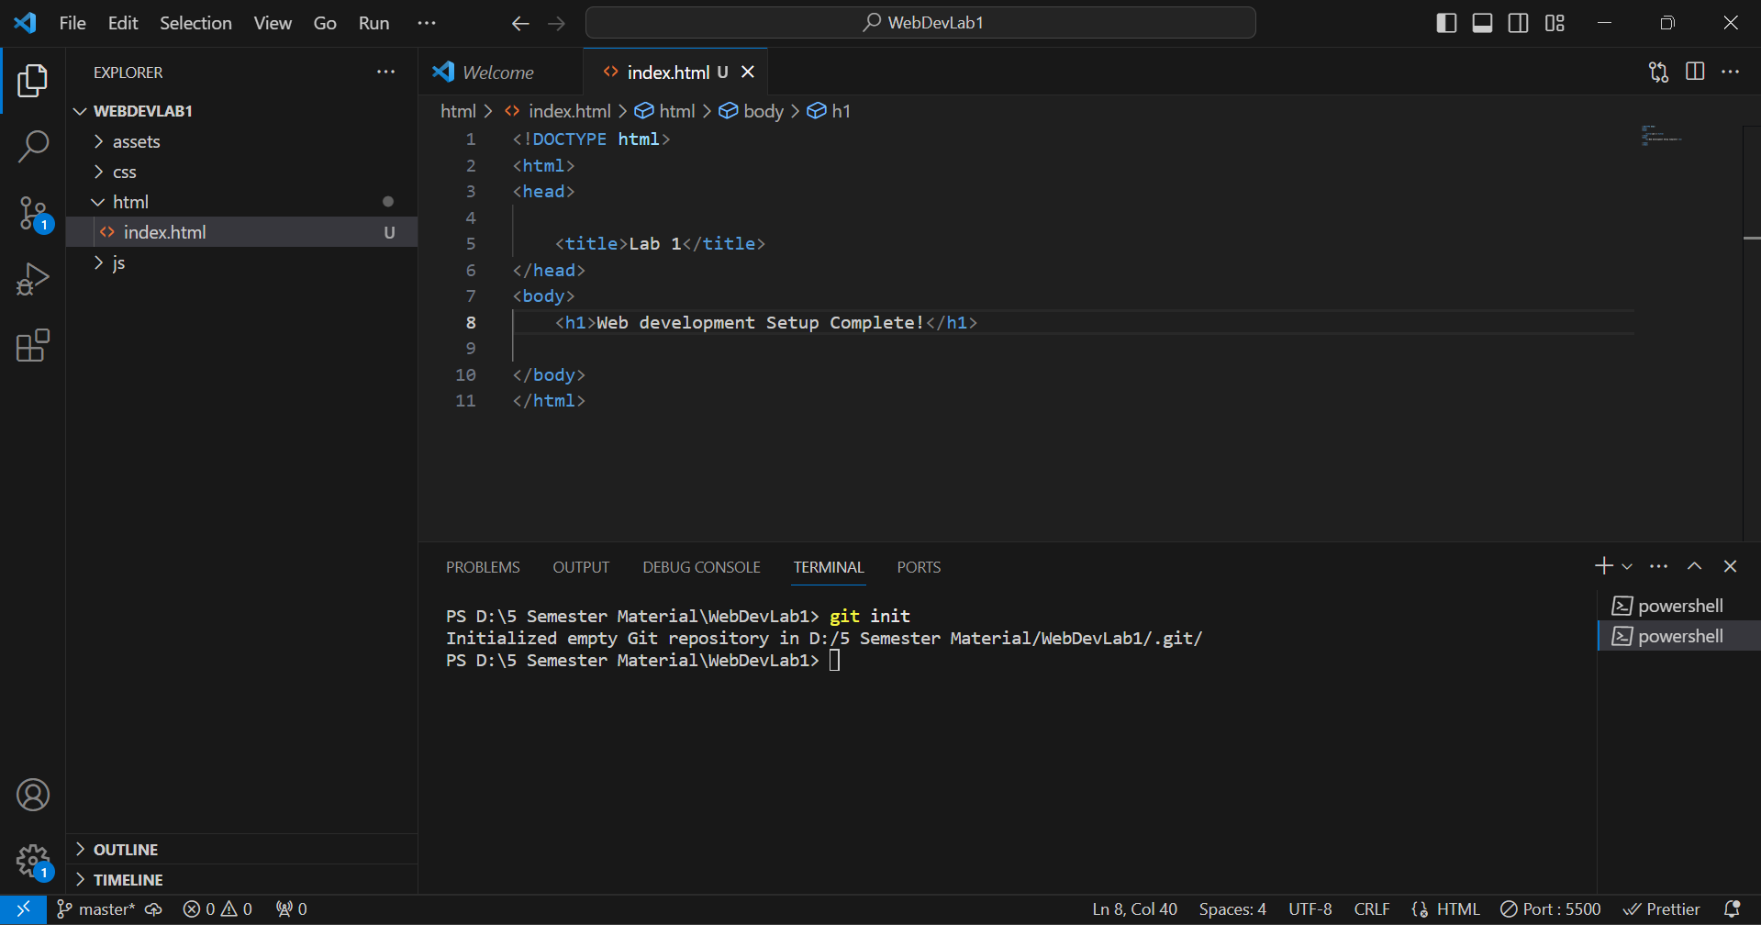

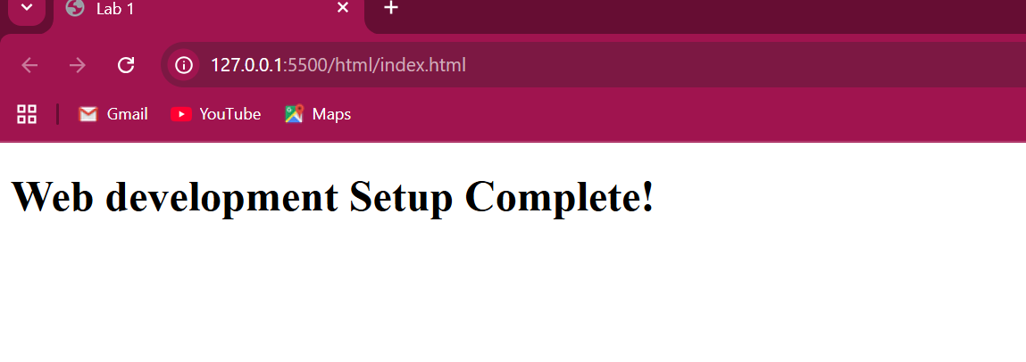

CONCLUSION:

Rubic:

Performance |  |  | Lab Report
Description | Total Marks | Marks Obtained | Description | Total Marks | Marks Obtained
Ability to Conduct practical | 5 |  | Structure | 5
Data Analysis s Interpretation | 5 |  | Efficiency | 5
Total Marks obtained |  |  | Total Marks Obtained

Instructor Signature

